**Linear Regression Overview**

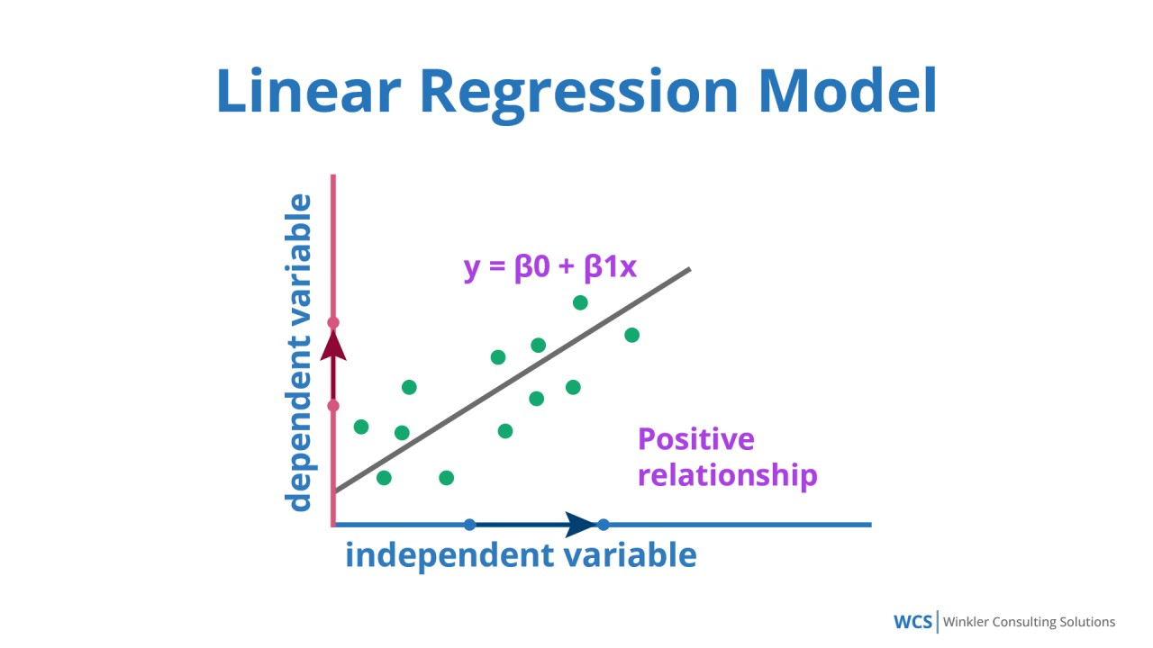

Linear regression is a simple yet powerful supervised learning algorithm used to model the relationship between a dependent variable (target) and one or more independent variables (features). The primary goal is to find the linear equation:

y=β0+β1x1+β2x2+⋯+βnxn+ϵy = \beta_0 + \beta_1x_1 + \beta_2x_2 + \cdots + \beta_nx_n + \epsilony=β0​+β1​x1​+β2​x2​+⋯+βn​xn​+ϵ

Where:

* yyy: Dependent variable (predicted output)
* x1,x2,…,xnx_1, x_2, \ldots, x_nx1​,x2​,…,xn​: Independent variables (features)
* β0\beta_0β0​: Intercept
* β1,β2,…,βn\beta_1, \beta_2, \ldots, \beta_nβ1​,β2​,…,βn​: Coefficients representing the influence of each feature
* ϵ\epsilonϵ: Error term (difference between observed and predicted values)

Linear regression assumes a linear relationship between variables and minimizes the error through a method called **Ordinary Least Squares (OLS)**, which minimizes the sum of squared residuals.

**Applications of Linear Regression**

1. **Predictive Analytics**: Sales forecasting, house price prediction.
2. **Trend Analysis**: Time-series data like stock price trends or temperature changes.
3. **Cause-and-Effect Studies**: Understanding the impact of independent variables like marketing spend on revenue.

**Strengths of Linear Regression**

* Easy to interpret and implement.
* Computationally efficient, especially for large datasets.
* Works well for linearly separable data.

**Limitations**

* Assumes linear relationships, which may not always hold.
* Sensitive to outliers and multicollinearity.
* Struggles with complex, non-linear patterns.

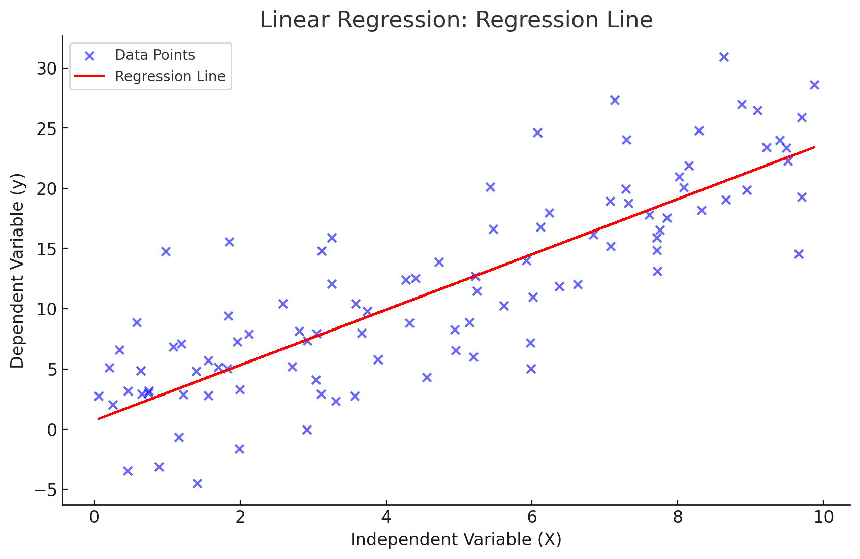

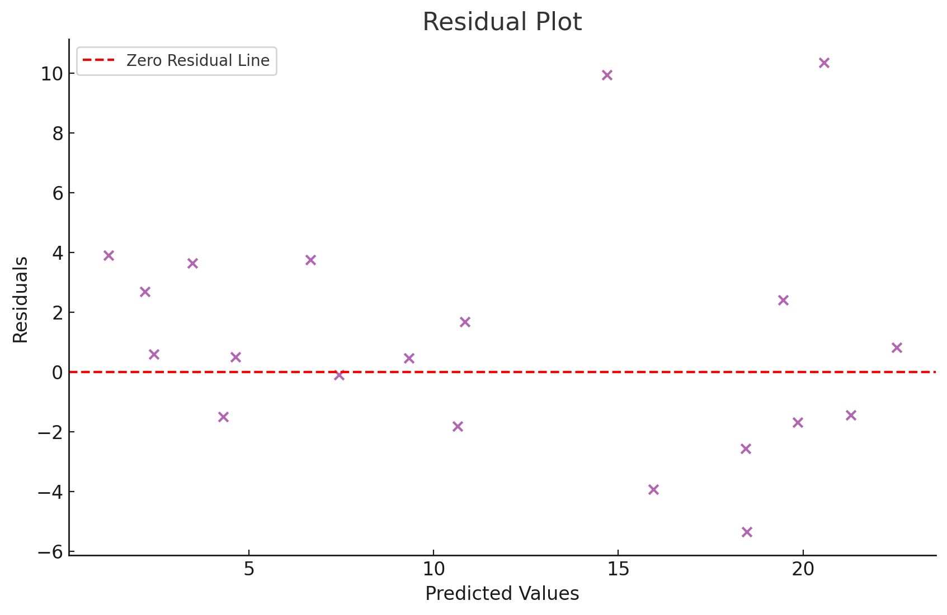

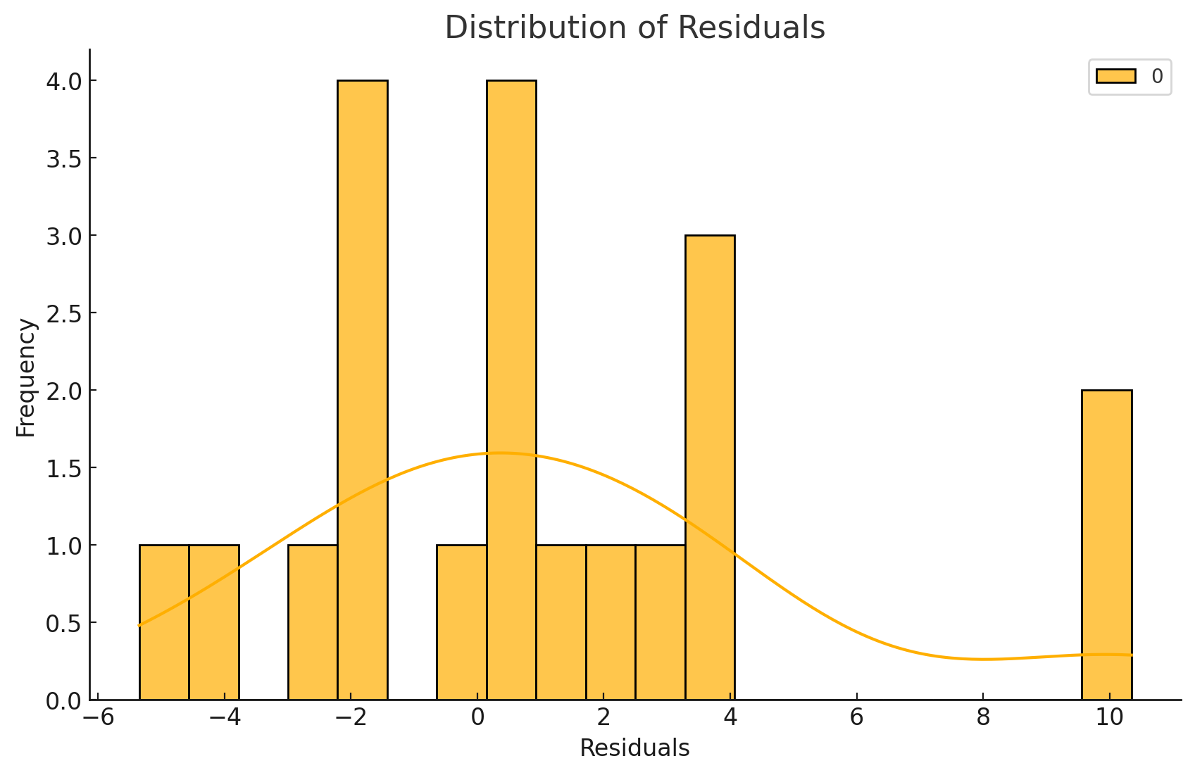

**Random Forest: Overview**

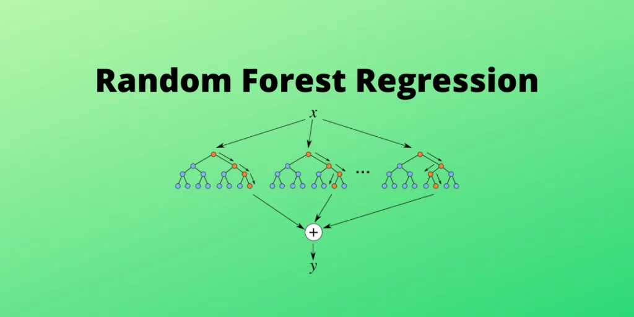

Random Forest is an ensemble learning method that combines multiple decision trees to create a more powerful and accurate predictive model. Each tree in the forest makes a prediction, and the final output is determined by aggregating the predictions from all the individual trees. In classification tasks, it uses a majority vote to predict the class, and in regression tasks, it takes the average of the individual trees' predictions.

The Random Forest algorithm is built on the principles of **bagging** (Bootstrap Aggregating) and **random feature selection**. Here's a detailed breakdown:

**How Random Forest Works:**

1. **Data Subsampling**:
   * The algorithm creates multiple subsets of the training data by bootstrapping (sampling with replacement). Each tree is trained on a different subset of the data, which helps reduce the risk of overfitting.
2. **Tree Construction**:
   * For each subset, a decision tree is constructed. However, at each node of the tree, the algorithm selects a random subset of features (instead of considering all the features) to find the best split. This randomness helps in reducing the correlation between individual trees, improving the model's generalization capability.
3. **Prediction**:
   * Once all the trees are built, each tree makes its own prediction. In classification problems, the class that gets the most votes across all trees is the final prediction. In regression problems, the average of all tree predictions is taken as the final result.

**Key Hyperparameters in Random Forest:**

* **Number of Trees (n_estimators)**: The number of decision trees to be constructed. A higher number of trees can improve the performance of the model, but it also increases computational cost.
* **Max Depth (max_depth)**: Controls how deep each individual tree can grow. Deeper trees can capture more complex patterns but are prone to overfitting.
* **Min Samples Split (min_samples_split)**: The minimum number of samples required to split an internal node. It prevents the tree from growing too deep and overfitting.
* **Min Samples Leaf (min_samples_leaf)**: The minimum number of samples required to be at a leaf node. It helps in reducing overfitting by smoothing the model.
* **Max Features (max_features)**: The maximum number of features to consider when looking for the best split at each node. A lower number of features can improve model robustness.

**Advantages of Random Forest:**

* **High Accuracy**: Random Forest typically provides high-accuracy predictions because it combines the results from multiple decision trees.
* **Robustness**: It is less prone to overfitting compared to a single decision tree because it averages out the errors.
* **Versatility**: Random Forest can be used for both classification and regression tasks.
* **Feature Importance**: The algorithm can help in assessing the importance of various features in making predictions.
* **Handles Missing Data**: Random Forest can handle missing data by considering only available data for making splits.

**Disadvantages of Random Forest:**

* **Model Interpretability**: Due to the complexity of the model (many trees), it is often considered a "black-box" model, making it difficult to interpret.
* **Training Time**: Random Forest can be computationally expensive, especially when there are a large number of trees and features.
* **Memory Usage**: Storing all the individual trees requires significant memory, particularly when dealing with large datasets.

Gradient Boosting

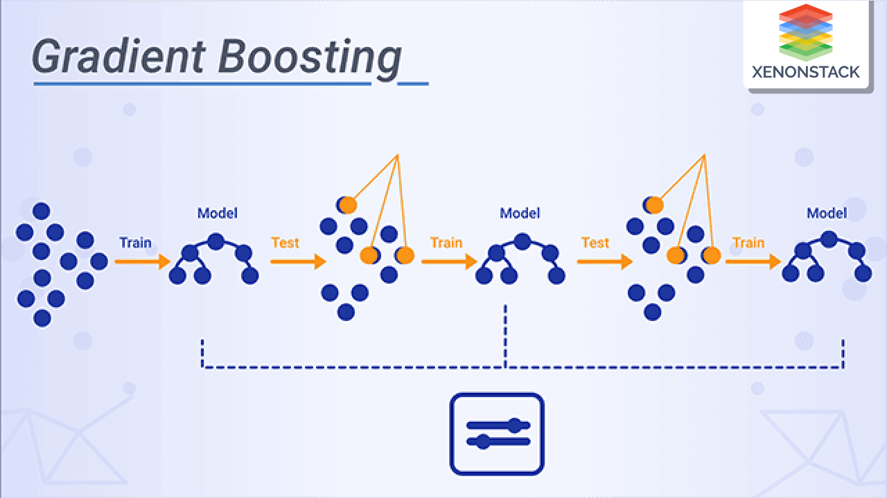

Gradient Boosting is a powerful ensemble machine learning technique that builds a strong predictive model by combining multiple weak learners, typically decision trees. It works by iteratively improving the model by focusing on the residual errors of the previous model. Each new model corrects the errors made by the previous ones, and the final prediction is the weighted sum of the individual models' predictions. Here’s how Gradient Boosting works:

1. **Initialization:**
   * Start by fitting an initial model, often a simple model like a mean prediction (for regression) or a constant (for classification).
2. **Error Calculation:**
   * Compute the residual errors of the initial model, which are the differences between the predicted values and the actual values.
3. **Fitting a New Model:**
   * Fit a new model (usually a decision tree) to predict the residuals, i.e., how the current predictions deviate from the actual values.
4. **Update the Prediction:**
   * Add the predictions from the new model to the existing model’s predictions, weighted by a learning rate to control how much the new model affects the total prediction.
5. **Repeat:**
   * This process is repeated for a number of iterations or until no significant improvement is made. Each subsequent model tries to correct the errors made by the previous ones.

**Key Hyperparameters in Gradient Boosting:**

* **Number of Estimators (Trees)**: The total number of decision trees (models) to be built.
* **Learning Rate**: Controls the contribution of each tree to the final prediction. A smaller learning rate requires more trees to model the data effectively.
* **Max Depth**: The maximum depth of the decision trees used in the ensemble. A deeper tree can model more complex patterns but may also lead to overfitting.
* **Subsample**: The fraction of samples used for fitting each individual tree. This parameter helps in reducing overfitting.
* **Loss Function**: The objective function (e.g., mean squared error for regression, log-loss for classification) that the model is trying to minimize.

**Advantages of Gradient Boosting:**

* **High Predictive Power**: Gradient Boosting typically produces high-accuracy models.
* **Handles Complex Data Well**: It can model complex relationships in the data, even with nonlinearities.
* **Feature Importance**: Like random forests, Gradient Boosting can also help assess the importance of different features in prediction.

**Disadvantages:**

* **Training Time**: Gradient Boosting can be computationally expensive, especially for large datasets, as each new model needs to be trained iteratively.
* **Overfitting**: If the number of trees is too high, or the learning rate is too low, the model can overfit the training data.